Summer Camp Calendar
First Day of Summer Camp Monday June 28th 2021
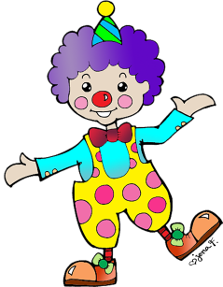
Last Day of Camp Friday August 27th, 2021
6/28 - 7/2
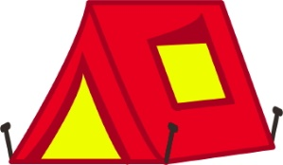
Week 1 Space is the Place

7/6 7/9
Week 2 Circus Time

7/12 - 7/16
Week 3 Let’s Go Camping

7/19 - 7/23
Week 4 Barnyard Palooza

7/26 – 7/30
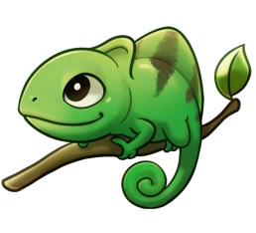
Week 5 Under the Sea
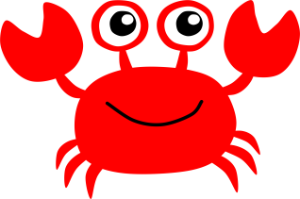
8/2 - 8/6
Week 6 A Reptiles Life

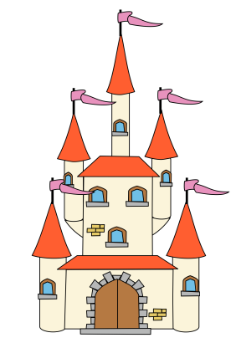
8/9 - 8/13
Week 7 Dinosaur Dig
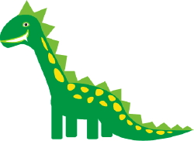
8/16 - 8/20
Week 8 Enchanted Kingdom

8/23-8/27
Week 9 Sports Week

Flexible Schedules available at Enrollment
Choose your weeks, choose your Days

